Step 1 :- Sign in to AWS Account

<https://signin.aws.amazon.com/signin?redirect_uri=https%3A%2F%2Fconsole.aws.amazon.com%2Fconsole%2Fhome%3FhashArgs%3D%2523%26isauthcode%3Dtrue%26nc2%3Dh_ct%26src%3Dheader-signin%26state%3DhashArgsFromTB_eu-north-1_522611e77e2d291b&client_id=arn%3Aaws%3Asignin%3A%3A%3Aconsole%2Fcanvas&forceMobileApp=0&code_challenge=9IbjLkDwSPZ5p9SWe-PveqynNv5PaUI_IIBU2gzi6dU&code_challenge_method=SHA-256>

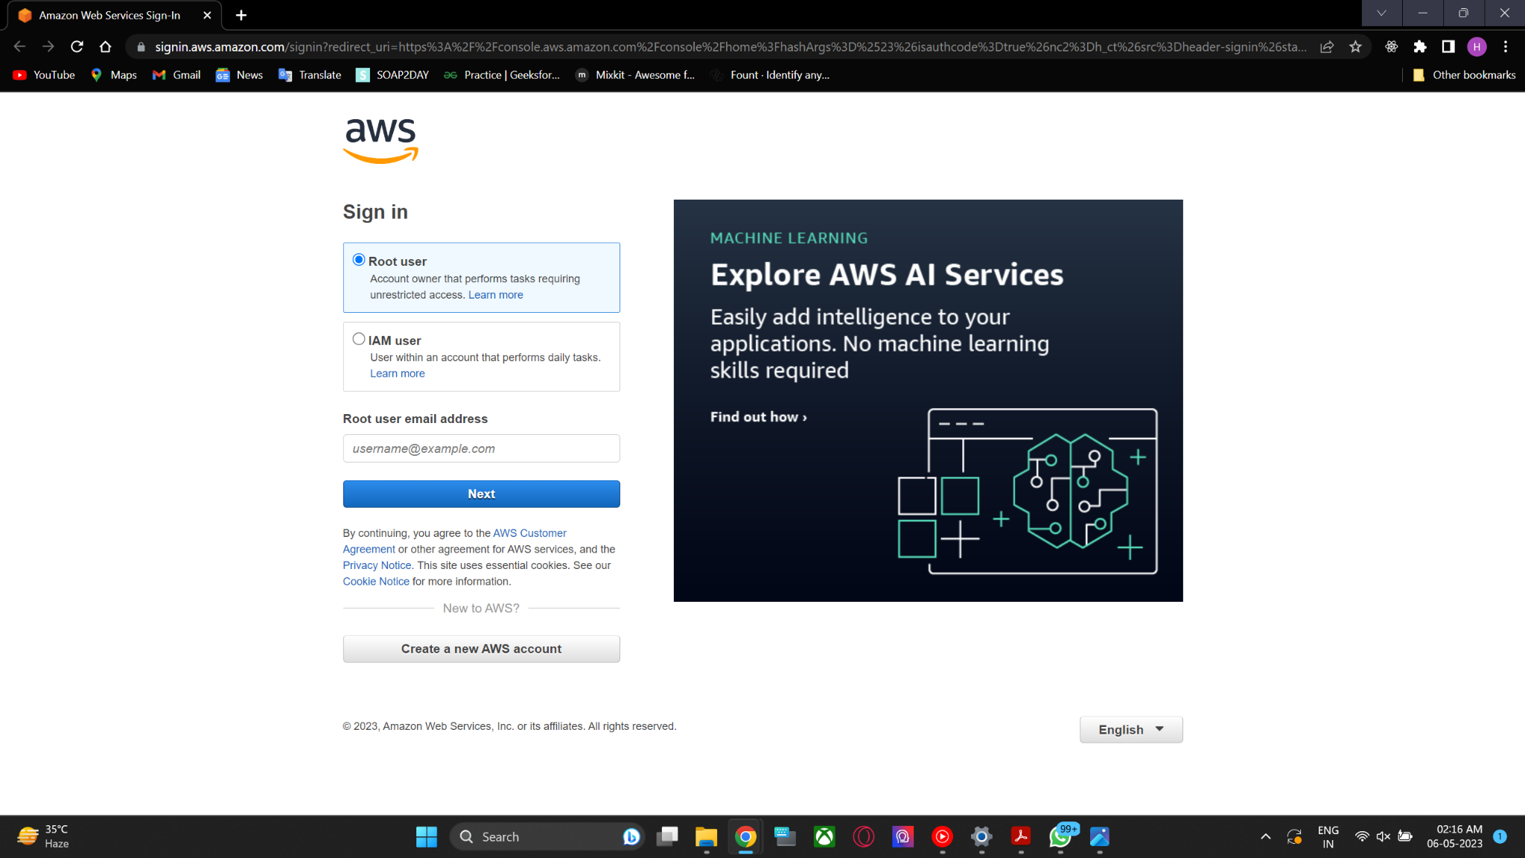

Step 2:-To run an instance, you can navigate to the AWS services menu, select the "Computing" option, and then choose "EC2". This will take you to the EC2 dashboard where you can launch and manage your instances.

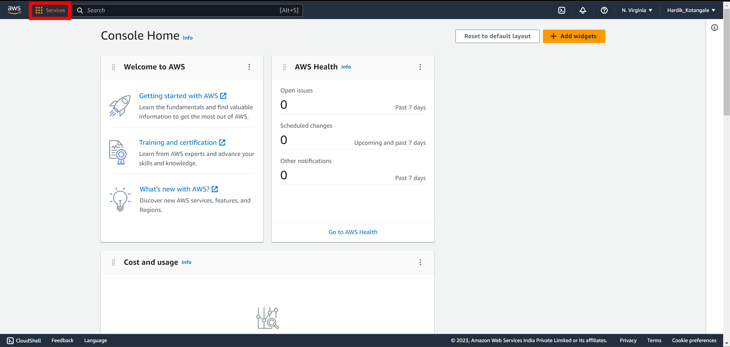

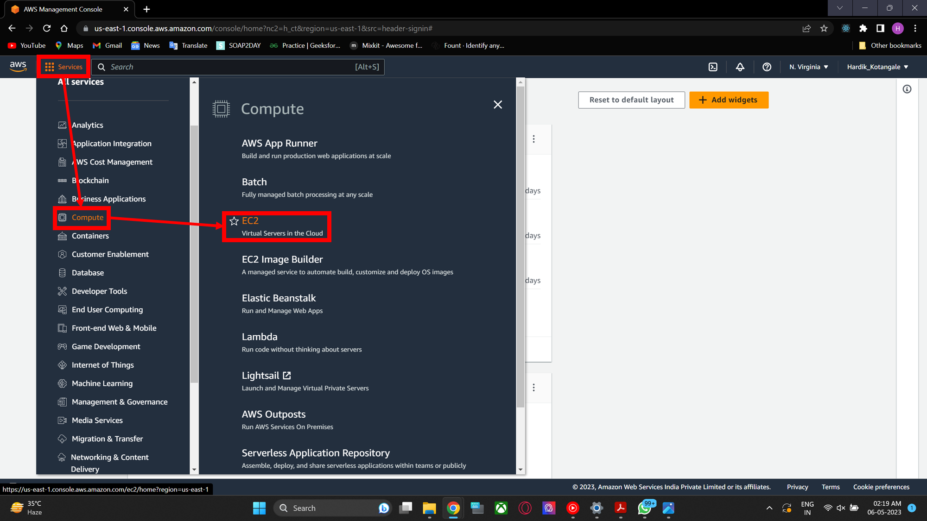

Step 3 :- To set up the instance, we have to click on "Launch Instance".

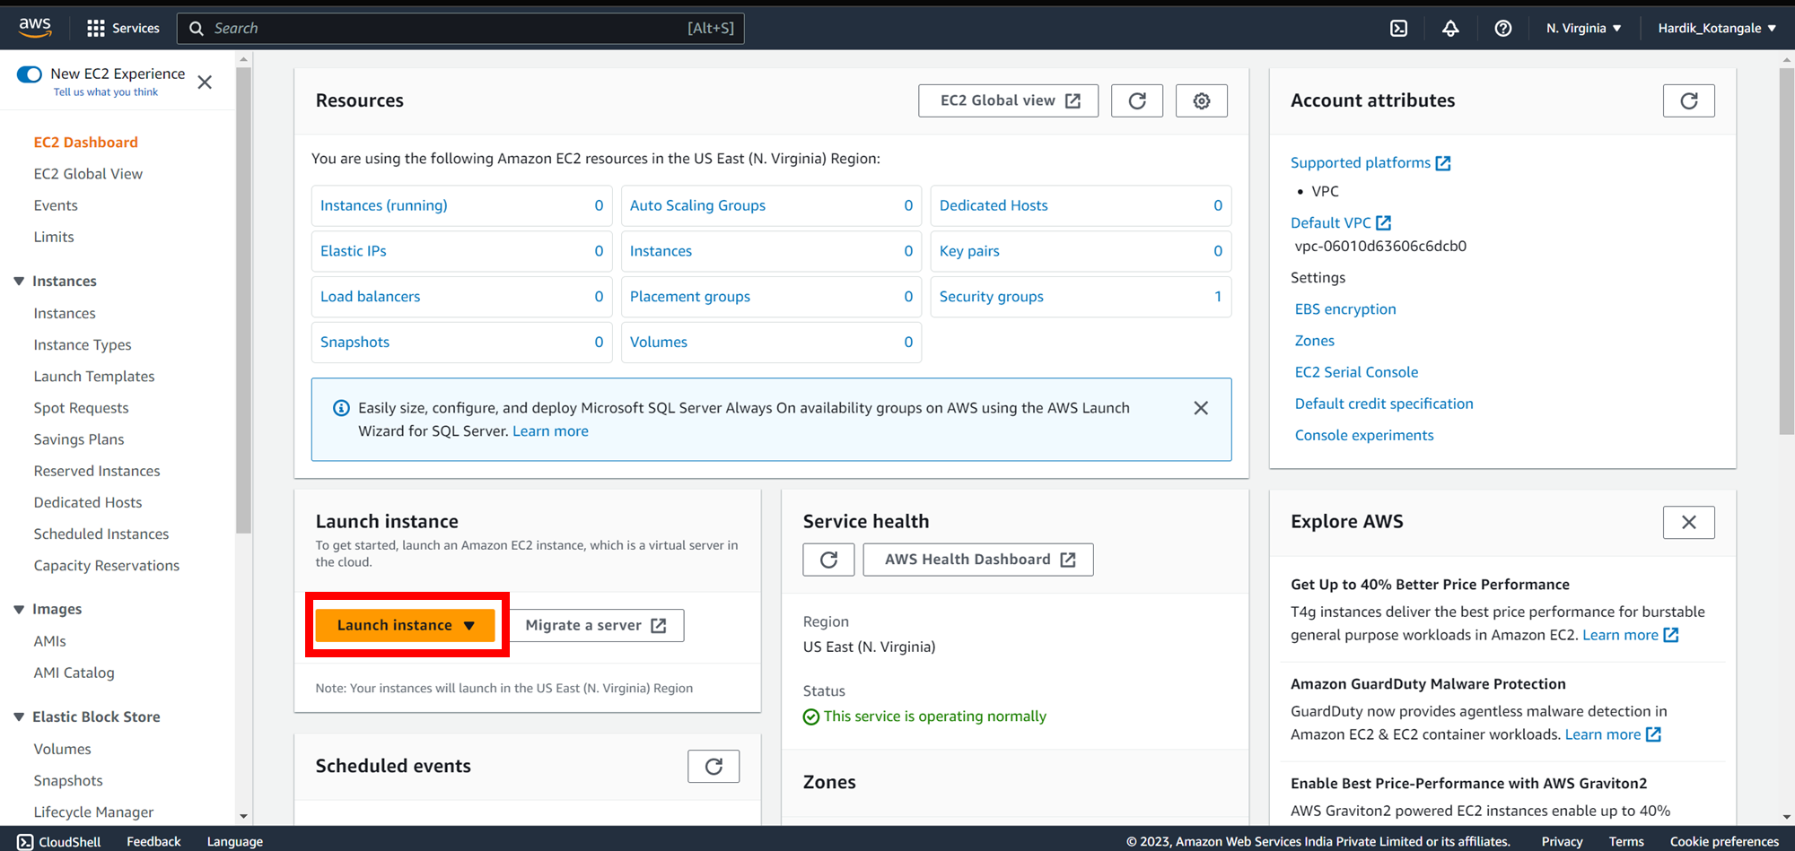

Step 4:- You need to provide a name for the instance. From there, you can select the operating system or application that you want to run on the instance.Then click on launch instance

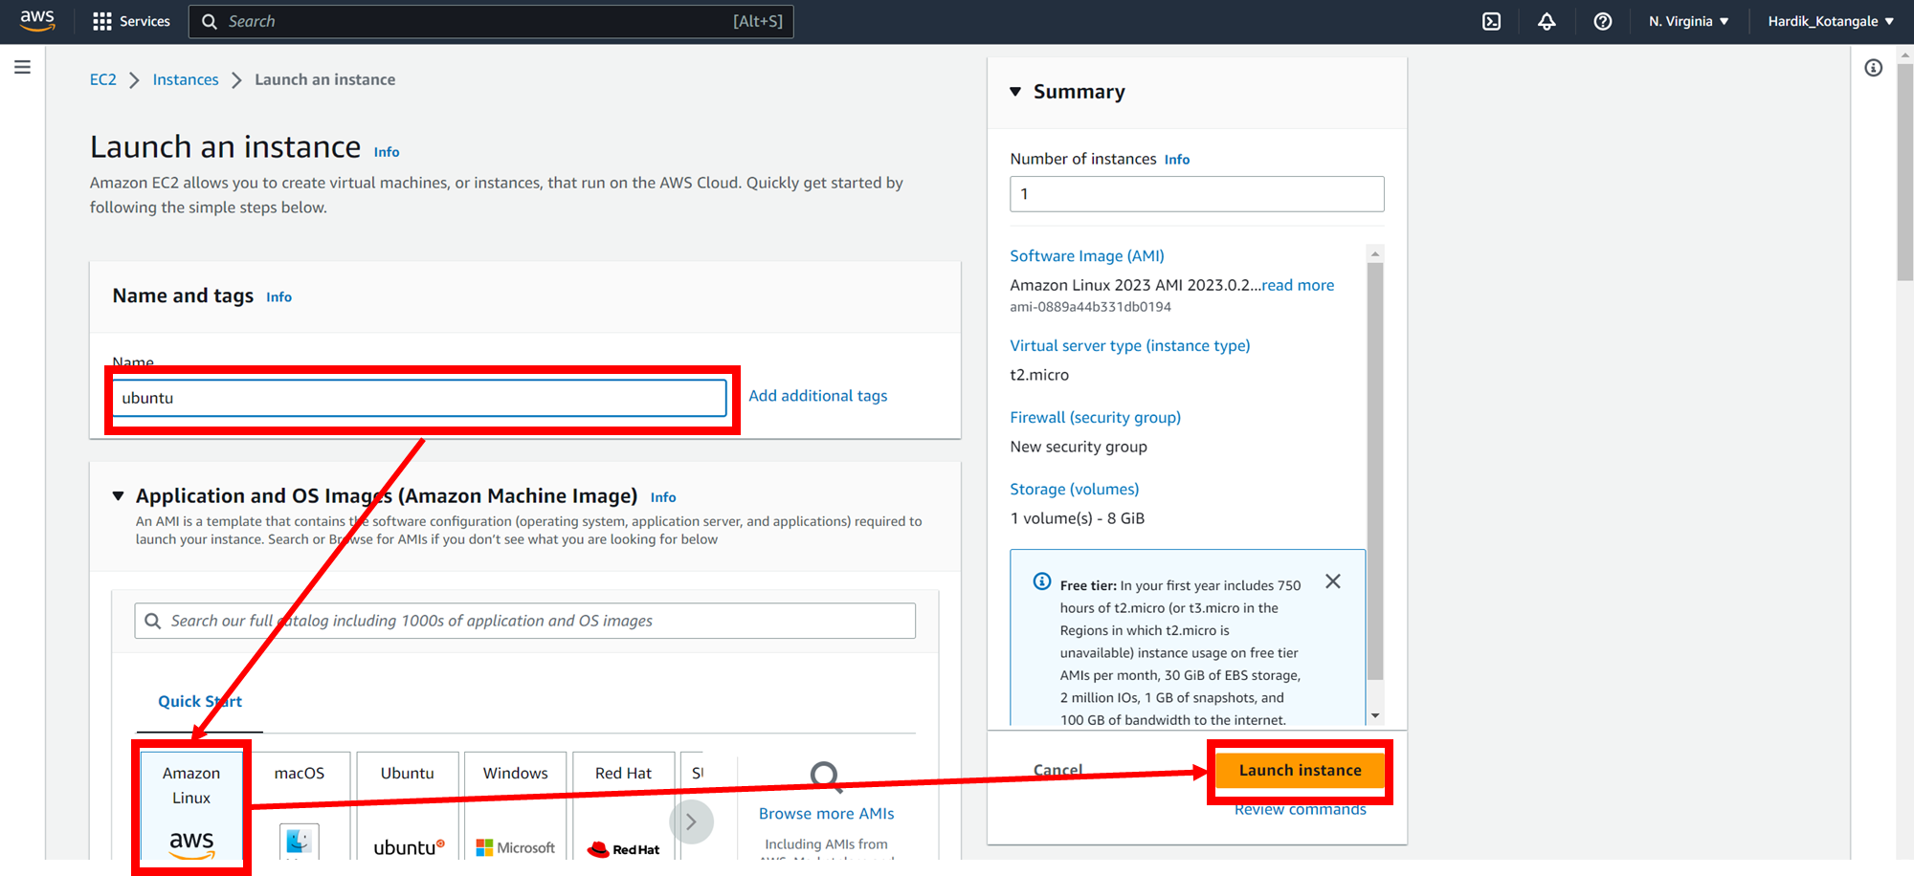

Step 5:-To proceed without a key pair, select the "Proceed without a key pair" option and click on it.

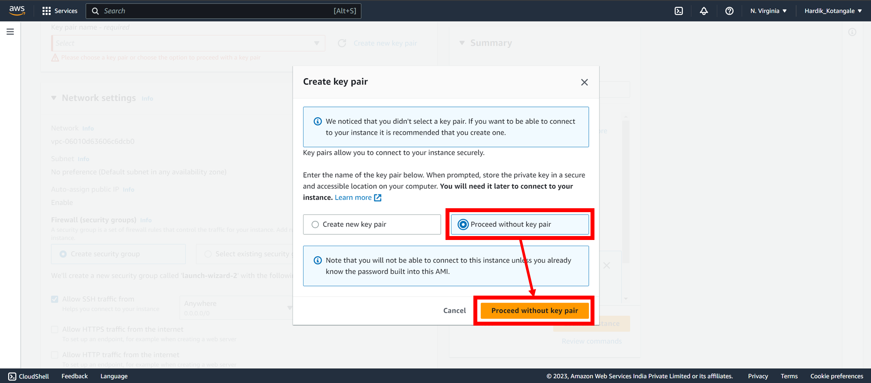

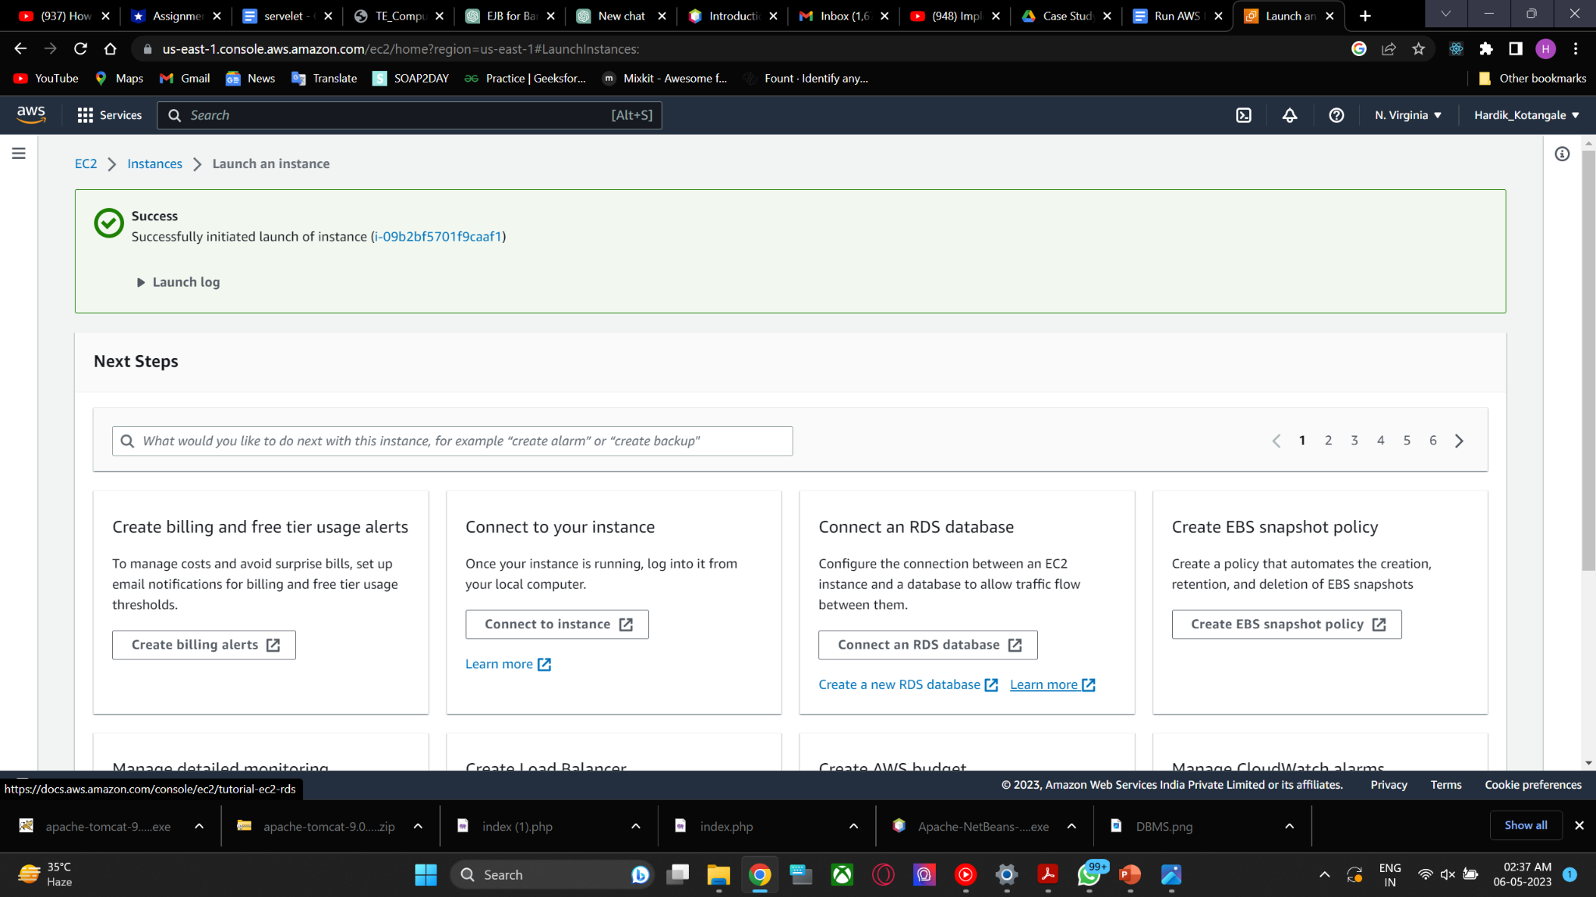

Step 6:- Monitor your instance

